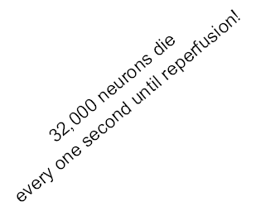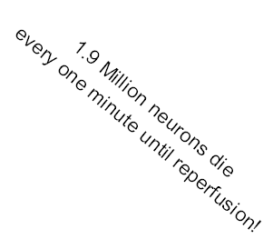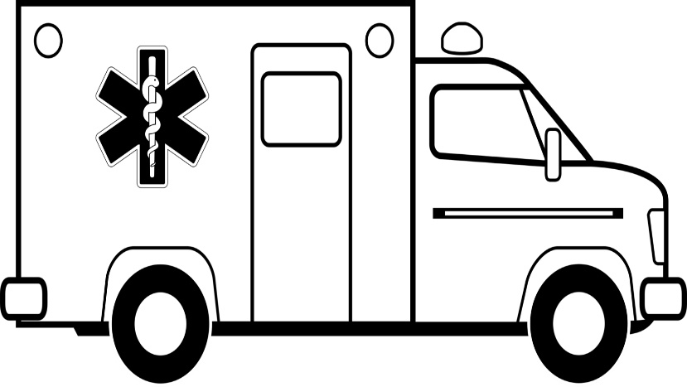

**STROKE: Door in Door out**

Goal <120 minutes 85% of the time

Congratulations!

Now let’s go for ___ %!

**90%**

EMS Agency Name

**100%**

**90%**

**80%**

**70%**

**60%**

**50%**

**40%**

**30%**

**20%**

**10%**

Percent of Patients

Your Hospital Name

Your logo here