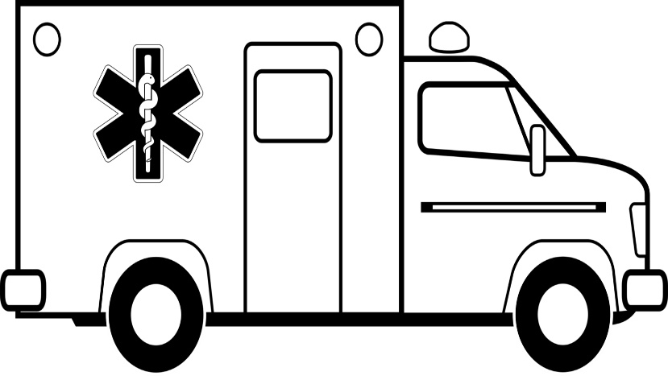

Your logo here

1.9 Million neurons die every one minute until reperfusion!

_____________________________________________

_____________________________________________

_____________________________________________

_____________________________________________

_____________________________________________

_____________________________________________

Physician

Nurse

Clerk

List Others

**__Minutes!**

**STROKE: Door in Door out**

Goal <120 minutes

EMS Agency Name

Your Hospital Name